OXFORDSHIRE COUNTY COUNCIL

ENSTONE PRIMARY SCHOOL
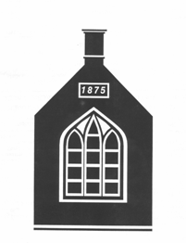  Headteacher: Mrs Sarah Mann |  | Oxford Road  Enstone  Chipping Norton  Oxon  OX7 4LP
Telephone: 01608 677268
Email: office.2103@enstone.oxon.sch.uk
www.enstone.oxon.sch.uk

April 2026

Dear Colleague,

Post of Experienced Permanent Full Time Teacher at Enstone Primary School

Thank you for your interest in this post, which will become vacant from September 2026. We are a popular small village school, currently with 83 children on roll, grouped in four classes. We employ four fte teachers, plus eight teaching assistants (some of whom work part time), a school business manager and a school office administrator.

Our school serves the village of Enstone and the surrounding smaller villages of Lidstone, Cleveley, Fulwell and Kiddington, as well as attracting pupils from outside of our catchment area. The original school building dates from 1875 but has since been extensively extended and refurbished to provide four well-equipped classrooms in the main building, offices, a staffroom, a library and group work and resource areas. Our EYFS classroom and school hall are situated in a second building, on-site, where there is also a curriculum kitchen for the use of the children and a catering kitchen serving hot meals daily.

The school is set in an attractive village location and benefits from a spacious playground, an attractive outdoor learning zone including a nature garden, pond garden and flexible outdoor teaching space, plus access to a large Fields in Trust playing field. As a village school, our rural setting and community links are strong and are an important part of our ethos.

Our committed and experienced teaching team and Governing Body are proud of the happy, friendly and caring environment we have created at Enstone Primary. We would strongly encourage you to visit our school, where a warm welcome awaits you. Please contact Hollie Reeve, our School Office Administrator, to arrange this.

We look forward to receiving your application by 12 noon on Tuesday 5th May 2026.

Interviews will be held on Monday 18th May 2026

Please read on to find out more about our school – and don’t forget to visit our website:

www.enstone.oxon.sch.uk

Our School Offers:

High standards of achievement and progress
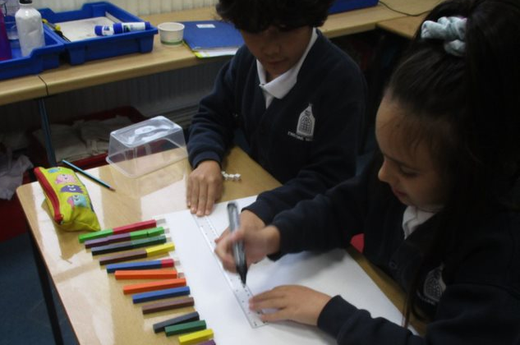
The Headteacher, Staff, Governors and Parents agree that the education we provide should develop the whole child and prepare them for life in modern Britain. Our standards across the curriculum are consistently high; assessment, tracking and target setting are rigorous and maintain a high profile in the planning and delivery of a creative, engaging and challenging curriculum.

At our most recent Ofsted inspection it was noted:

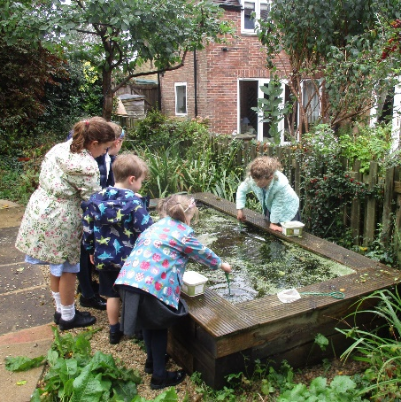
“You have successfully created a culture where high academic standards are supported by good-quality pastoral care.”

“Teachers know pupils exceptionally well and provide interesting work that challenges them effectively.”

Throughout the school a wide range of intervention and support strategies and bespoke learning journeys ensures that all pupils can achieve success and fulfil their potential.

A rich and varied learning experience for every pupil

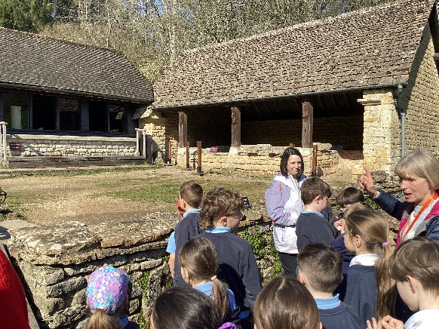
At Enstone Primary School we seize every opportunity to enrich and extend the curriculum. Regular school trips and visiting experts help to motivate the children in all subjects and our bi-annual residential trips for Y3/4 and Y5/6 are tremendously successful in raising independence and self-esteem. Regular themed days such as “World Book Day”, plus focus activities such as the Kingham Sculpture project or Chipping Norton Music Festival contribute to very positive learning behaviours and outcomes for our pupils.

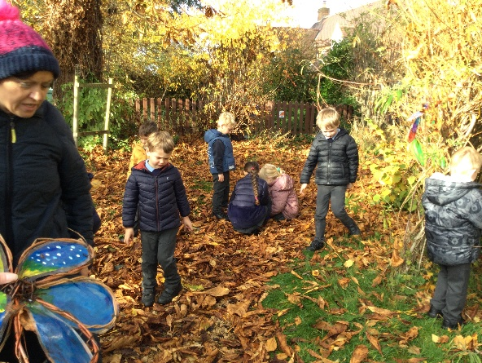
A wide variety of lunchtime and after school extra-curricular activities (both internally and externally run) are also on offer, including many sports clubs, arts and crafts, and musical opportunities. We have an active School Council and children are also encouraged to play a leading role in the school’s development by becoming “Eco Warriors”. The children are proud of the democratic nature of our school. Our “Play Leaders” and “Sports Leaders” schemes also help to foster a strong sense of responsibility and promote positive interactions between our pupils.

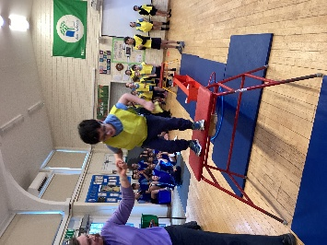
The House System we operate here at Enstone Primary School also promotes cohesion and team spirit throughout the school. Developing a sense of community and citizenship is very important to us, and we encourage the children in actively supporting a wide range of national and global charities, e.g. Farm Africa, Oxfam, Water Aid, as well as more locally based charities such as the local community food bank. Our annual House Festival is always a popular date in the calendar year, celebrating sports, the arts, music and, most importantly, great teamwork.

A commitment to sports and active lifestyles

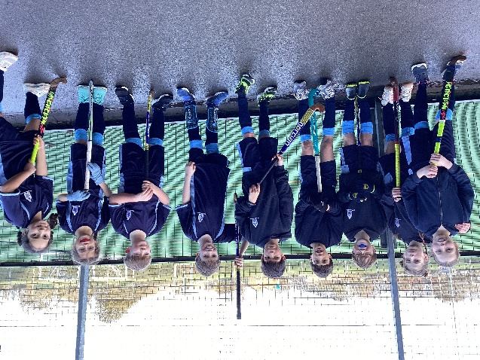
Pupils at Enstone Primary School benefit from a high-quality P.E. curriculum and a wide variety of extra-curricular sporting activities. Our links with the Chipping Norton Partnership of Schools our involvement in the Youth Sports Trust provide many opportunities for children to participate in coaching sessions, festivals and tournaments, often in partnership with the secondary school pupils and teachers. We encourage as many children as possible to join in our wide range of after school sporting activities, and we have held the School Games Gold Sports Mark for many years now.

A commitment to the Arts
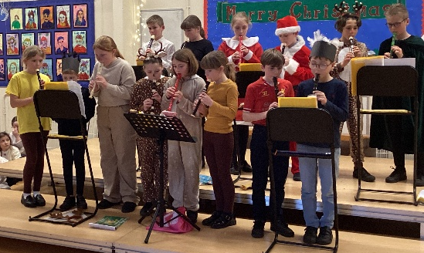
A strong emphasis is placed on music and performing arts at Enstone Primary School. We regularly participate in partnership events, festivals, workshops and concerts. We offer a range of opportunities for children to learn to play musical instruments, including woodwind and brass lessons with tutors from “Music for Schools Foundation”, guitar and ukulele lessons with “Create Music” and recorder groups and a popular school choir led by school staff.
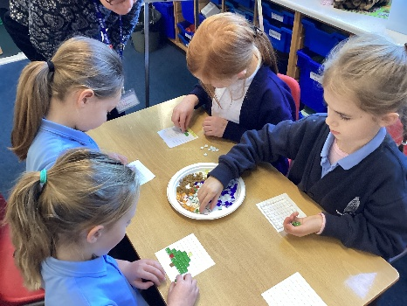
Through a partnership with CATS (Cotswold Arts through Schools), our curriculum is further enriched by opportunities for children to work with visiting artists and explore a wide range of creative skills and media. Recent projects have included charcoal sketching, acrylic and water-colour painting, clay sculptures and mosaic making.

We encourage all children to participate in the many and varied activities on offer, and the performing arts enjoy high status amongst our pupils.

A solid partnership with parents and the wider community

Enstone Primary School benefits from a supportive school community. Our “Friends” association work with us to provide lots of additional resources and opportunities for our pupils, including arranging a wonderful sesquicentenary fete in the summer of 2025.

The Future

Ofsted judges us to be a good school and we are committed to building on our successes and continuing to move the school forward. We continue to innovate in terms of our curriculum and to further raise standards of learning, achievement and progress.

Could you be the person we are looking for to join our teaching team and be a part of shaping our future? We look forward to hearing from you.

Yours sincerely,
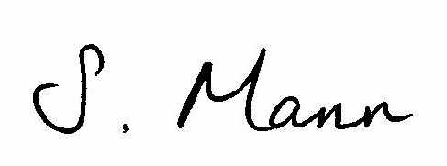

Sarah Mann

Headteacher

