A SAFEGUARDING FORM MUST BE COMPLETED ALONGSIDE THIS BODY MAP
Pupil’s name:___________________________________
Date and time:__________________________________
Completed by:__________________________________
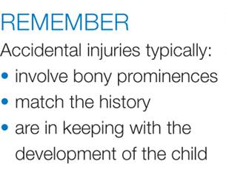
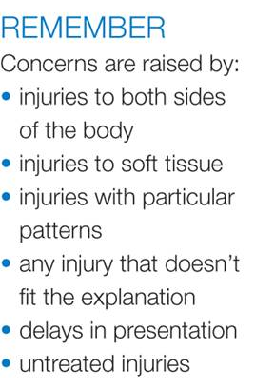
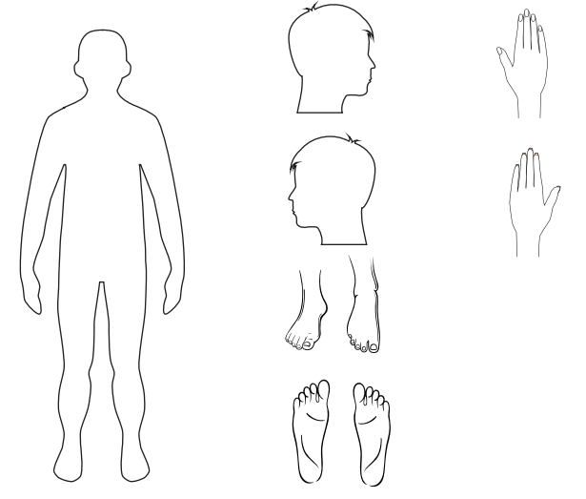
Notes:

